1. Determine your website goals

I am a computer vendor. My name is Dell. I want a simple display site for my computer product. You can include a home page, Desktop, Laptop, About Us and contact us. I want a simple and generous highlight of the product and a web page that summarizes the performance of the product

2. Now list out the web page components

Home page Desktop Laptop About Us Contact Us.

1. Now storyboard the layout and include: position, size (in % if looking for a responsive website), layout (can also include colors and “look” or style information, site map etc…)

storyboard

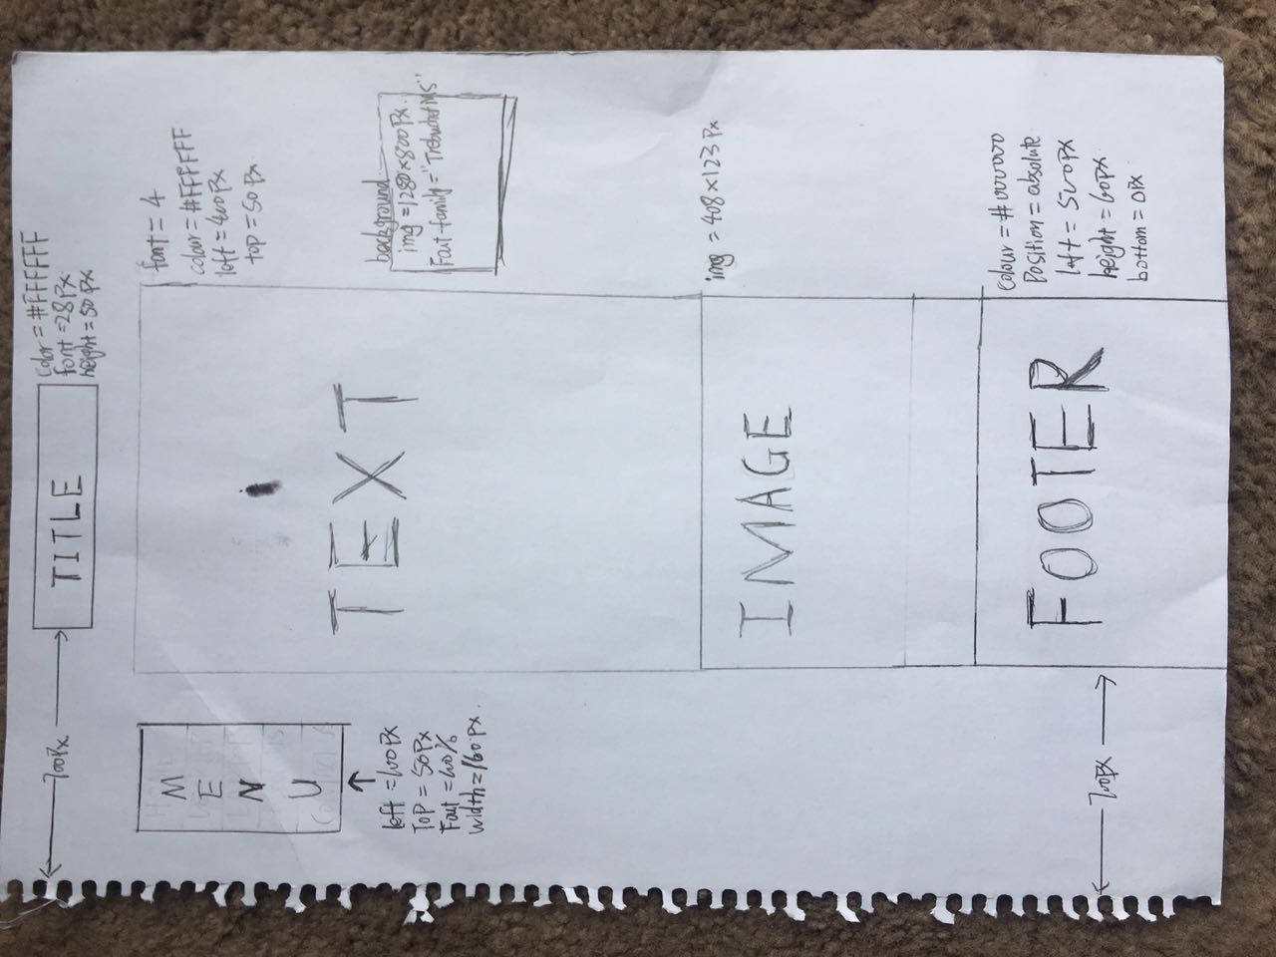

4. Read the Mozilla Developer network page to assist you in converting storyboard to HTML template.

<https://developer.mozilla.org/en-US/docs/Learn/HTML/Introduction_to_HTML/Debugging_HTML>

There is a brief skeleton example of a template on Blackboard Week 3 in Weekly Content

5. Create template

|  |  |
| --- | --- |
| HTML Template: | |
| Document type, Head  Body | <!DOCTYPE html>  <html>  <head>  <meta charset="utf-8">  <meta name="viewport" content="width=device-width, initial-scale=1.0">  <meta http-equiv="X-UA-Compatible" content="IE=edge">  <title>DELL</title>  <link href="./static/css/main.css" rel="stylesheet" type="text/css" />  </head>  <body> |
| Banner | <h2>DELL</h2> |
| Footer | <div>  <footer><i>Copyright © Jiaqi Wang 2017</i></footer>  </div> |
|  |  |

6. Validate the template with the W3schools validation link <https://validator.w3.org/>

Choose HTML5 (experimental) and UTF-8 options